BLOOD DONATION MANAGEMENT SYSTEM

ABSTRACT
The Blood Donation Management System is a computerized system designed to efficiently manage and streamline the process of blood donation, storage, and distribution. The system aims to bridge the gap between blood donors, blood banks, and recipients by providing a centralized platform for real-time data management. It maintains detailed records of donors, blood groups, donation history, inventory levels, and recipient requests, ensuring quick and accurate access to critical information. By automating tasks such as donor registration, blood stock monitoring, request processing, and reporting, the system reduces manual effort, minimizes errors, and improves operational efficiency. Additionally, the system enhances transparency, ensures timely availability of blood during emergencies, and supports better decision-making for blood bank authorities. Overall, the Blood Donation Management System contributes to improved healthcare services by ensuring safe, reliable, and efficient blood supply management.
INTRODUCTION
Blood donation plays a vital role in modern healthcare, as it is essential for saving lives during medical emergencies, surgeries, accidents, and the treatment of various diseases. Despite its importance, many hospitals and blood banks still rely on manual or semi-automated systems to manage blood donation records and inventory, which can lead to inefficiencies, data inaccuracies, and delays in providing blood to patients in need.

The Blood Donation Management System is designed to overcome these challenges by providing a centralized, automated, and efficient platform for managing blood donation activities. The system enables proper registration of donors, maintains accurate records of blood groups and donation history, and monitors blood stock levels in real time. It also helps blood banks quickly respond to blood requests and ensure the availability of safe and compatible blood.
EXISTING SYSTEM
In the existing system, most blood donation and blood bank processes are handled manually or with limited computer support. Donor records, blood group information, donation history, and blood inventory are often stored in paper files, exercise books, or basic spreadsheets. When a patient requires blood, hospital staff or blood bank personnel must search through these manual records to find a suitable donor or available blood group, which is time-consuming and error-prone.
DISADVANTAGE
- Manual record keeping is time-consuming and inefficient.

- High chances of data errors, duplication, and record loss.

- Blood availability cannot be tracked in real time.

- Emergency blood requests may face critical delays.

- Poor coordination between donors, blood banks, and hospitals.

PROPOSED SYSTEM
The proposed Blood Donation Management System is a fully computerized and centralized system designed to efficiently manage blood donation activities. This system allows easy registration of donors and maintains accurate records of donor details, blood groups, and donation history. It provides real-time monitoring of blood stock levels, helping blood banks quickly identify available blood units.
The system enables hospitals and recipients to place blood requests online, ensuring faster response during emergencies. Automated search and filtering options help in finding compatible blood groups without manual effort. The proposed system reduces paperwork, minimizes human errors, and improves data security.
ADVANTAGE
- Provides fast and easy access to donor and blood inventory information.

- Reduces manual work and minimizes human errors.

- Enables real-time tracking of blood stock availability.

- Improves response time during medical emergencies.

- Enhances coordination between donors, blood banks, and hospitals.

SYSTEM ARCHITECTURE
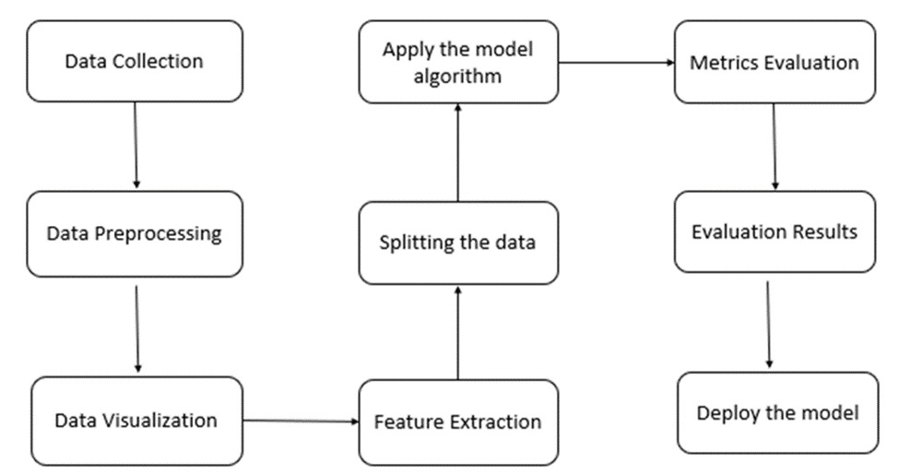

HARDWARE REQUIREMENTS
Processor (CPU) Intel Core i5/i7 or equivalent, 2.5 GHz
RAM Minimum 8 GB
Storage At least 500 GB HDD or SSD

SOFTWARE REQUIREMENTS
Operating System Windows 10/11,
Programming Languages Python 3.x
Web Framework Flask

